# CS 255 System Design Document Template

This template lays out all the different sections that you need to complete for Project Two. Each section has guidance to prompt your thinking. You will need to continually reference the interview transcript as you work to make sure that you are addressing your client’s needs. There is no required length for the final document. Instead the goal is to complete each section based on what your client’s needs are. Remove this note when you are finished, and replace all bracketed text with the relevant information.

## UML Diagrams

### UML Use Case Diagram The system was divided into smaller sub-systems to enhance the clarity of the Use Case diagrams.  
  
  
  
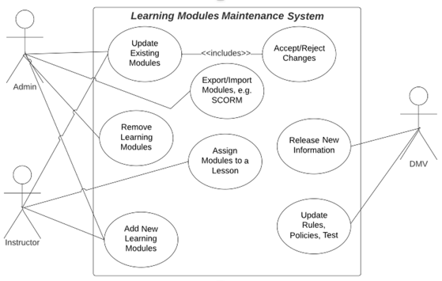 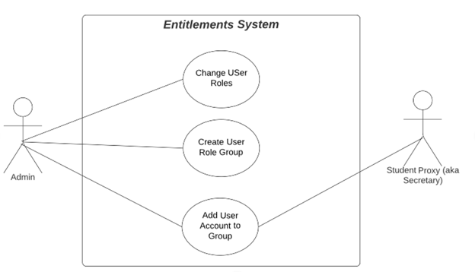  
  
  
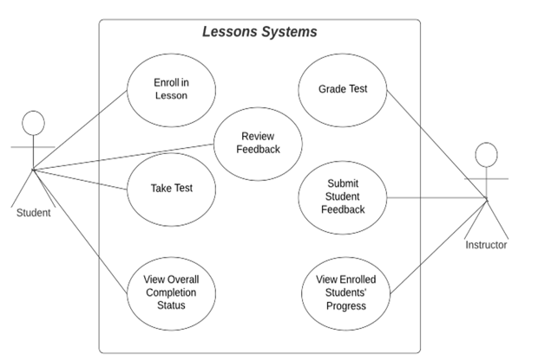 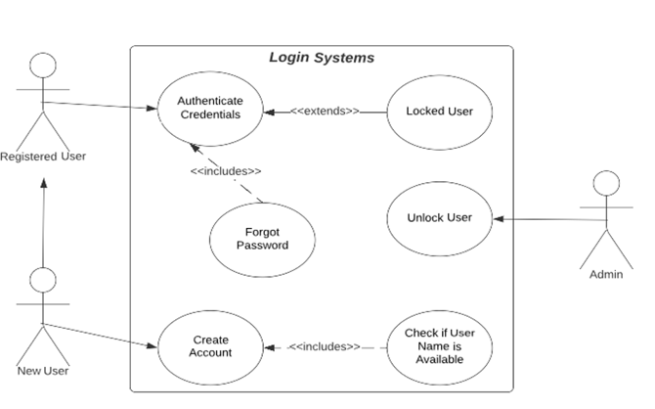

### UML Activity Diagrams The chosen use cases for the Activity Diagrams include a user logging in followed by navigating through the reservation process.

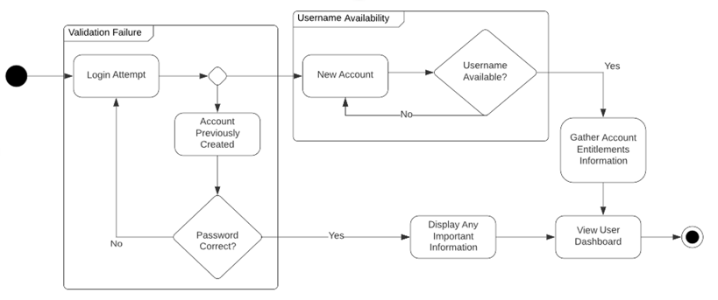  
  
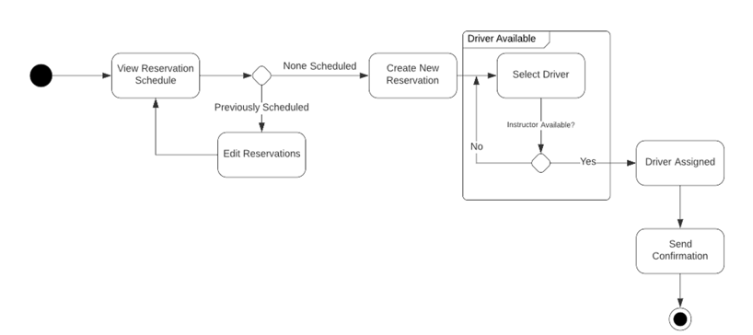

### UML Sequence Diagram The selected workflow for creating sequence diagrams involves the process of an individual trying to log in.

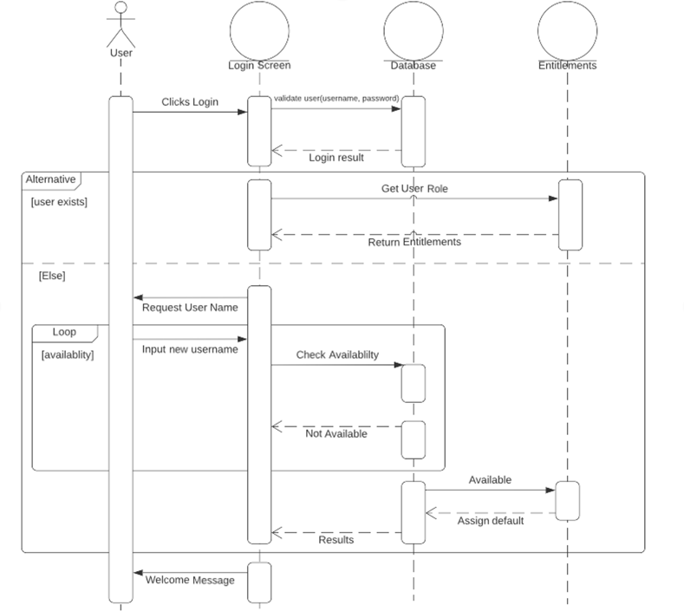

### UML Class Diagram At present, the following classes seem necessary:

### User (Abstract Class)

### Student and Instructor (Derived Classes of User)

### Vehicle

### Reservation

### Instruction (Abstract Class)

### Test and Lesson (Derived Classes of Instruction)

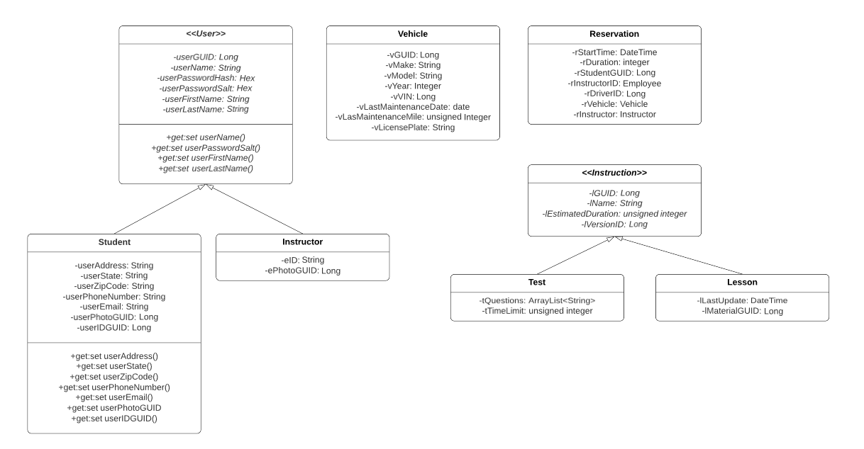

## Technical Requirements

The necessary technical specifications for a web-based Learning Management System (LMS) include:

* A Linux-based web server using Infrastructure as a Service (IAAS) on a third-party hosting platform like AWS or Google
* A scalable architecture, for instance, using Docker with Kubernetes
* APIs developed with RESTful methodologies
* Adherence to the SCORM standard by the LMS
* Implementation of hybrid RSA-encrypted AES public key encryption
* Encryption of all router traffic using TSL 1.2 or higher
* Compliance of all pages with Progressive Web Apps (PWA) standards
* Compatibility testing of all pages with iPhone 11 Pro iOS 14.6
* Compatibility testing of all pages with Samsung Android S10
* Compatibility testing of all pages with Chrome version 102.0.X
* Setting a Key Performance Indicator (KPI) for uptime at a minimum of 99.5%
* Exports of reports in CSV format